Exhibition Review

Published online 10 Feb 2021

Exhibition Review
Jessica Hemmings
This writing attempts to build a commentary of contrasts. I have based my thoughts about If We Asked about the Sky on memories of work I saw during a pre-pandemic studio visit, coupled more recently with hearing Anne Wilson’s reflection of her physical and emotional experience of the exhibition. My thoughts about Kustaa Saksi’s First Symptoms come from an exhibition visit one cold weekend in early 2020, half-awake and blissfully unaware that this would be one of the last exhibitions I could see in person this year (Figure 1). As a result, this writing breaks with the conventions of an exhibition review. I did not see Wilson’s exhibition in person; I visited First Symptoms without an exhibition review even in mind; and I have eschewed the reviewer’s typical position of objectivity in favor of dialogue by inviting the artists involved to comment on this text prior to publication. These “compromises” represent my effort to come to terms with the extent of isolation and loss 2020 has delivered. As an exhibition review, this writing is an adaptation of the genre, an attempt to make do with what remains possible today.
Figure 1. Kustaa Saksi, First Symptoms exhibition installation view, Galleri Format, Oslo, Norway, 2020.
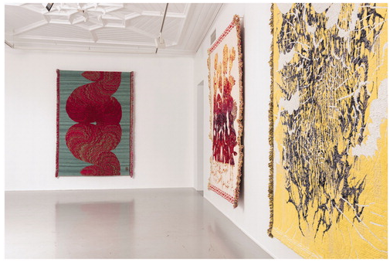
After the textile, it may not be immediately apparent what the practices of Anne Wilson and Kustaa Saksi share. Esthetically, both recent exhibitions carry the potential to be read through the Covid-19 pandemic. The viral load of moisture droplets, gene sequencing, anything quite frankly which suggests a visual representation of ill health. While readings such as these would allow us to compliment both artists’ prescience, over-seeing in this manner is unfair. The changes Covid-19 have brought are irrevocable, but there was a time before this pandemic. It was in this time that most of the exhibited works were made, albeit no longer the time in which they circulate.
Created between 2018 and 2020, Wilson’s series of embroidery and ink on damask cloth are meditations in two extremes: spill-time and stitch-time. Ink flicked across absorbent white damask quickly pulls through thirsty fibers to create a feathering around the droplets. Rather than suture or embellish existing damage on cloth as Wilson has previously, in this latest series chance ink patterns have been selectively over-stitched. The entire series demands acute attention. The slow intention of Wilson’s stitches follows the speedy and unpredictable marks of ink. But from a distance stitch and ink are difficult to differentiate—even close viewing does not always make discernment easy.
Saksi’s 2019 series of six large scale Jacquard weavings (three exhibited in Galleri Format) represent part of a longer investigation into what he has described as “action-painting with warp and weft.” ¹ The coinage is of course an intentional contradiction. Where Wilson’s use of ink has evoked literal associations with action painting ² (the spontaneous painting movement famously associated with the exuberance of artists such as Jackson Pollack) Saksi’s connection is produced through the pre-planned minutia of Jacquard weaving. It is here that the two artists meet—certainly not through technique or necessarily even content—but a shared interest in how both speed and deliberation may be simultaneously manifest in textiles.
In May 2020, the status of Wilson’s fifth solo exhibition at the Rhona Hoffman Gallery was: indefinitely postponed. Three weeks prior to what became the show’s opening date an adapted exhibition approach was confirmed. In the place of an opening event or subsequent group visits, the gallery produced a virtual walk through for online visitors and, together with neighboring galleries in the west town area of Chicago, used a restaurant table booking app. to allow visitors to reserve in-person viewing times. Wilson spent most afternoons of the five-week show meeting masked visitors, in person, seated at a distance of six feet in the gallery. The chairs used for these conversations remained in the exhibition space throughout—one concrete reminder of the changes we are all learning to live by (Figure 2).

Figure 2. Anne Wilson, Exhibition installation at Rhona Hoffman Gallery, Chicago, USA, 2020
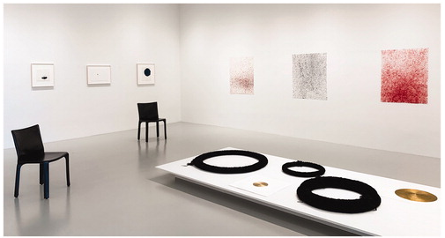

Twenty textiles—a mix of framed and unframed—were presented at eye level, while the eponymous work of the exhibition, If We Asked about the Sky (Figure 3), was installed high enough to require viewers to look up at the work, and Absorb/Reflect necessitated viewers peer downward to the floor. If We Asked about the Sky is a large damask cloth flecked with ink and stitched with human hair. Wilson suggests the “work proposes both smallness and vastness and inhabits a space of contemplation between the mortal world and a celestial universe that is infinite and unknowable.” ³ In many other works we also see the micro-level of the droplet in indigo colored ink or the crimson blood of an embroiderer’s pricked finger (Figure 4), as well as the human hair which Wilson first began embroidering into works from the early 1990s. Made after my autumn 2019 studio visit, Absorb/Reflect draws on earlier works Wilson made at the height of the HIV/AIDS epidemic in the late 1980s as, she explains, a “gesture of care and remembrance to someone grieving.” ⁴ Sharing the same floor plinth with the black ribbon garlands are several gold roundels: disks of hope in these dark times.

Figure 3. Anne Wilson, If We Asked About the Sky, 2020, Damask tablecloth, ink, hair embroidery, 5 x 9 feet, Photo: Jake Silby.
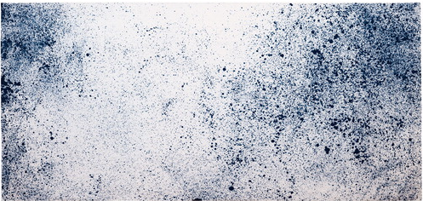

Figure 4. Anne Wilson, Material Drawing no. 1.26 (detail), 2018-2020, Damask cloth, ink, thread, 12 x 17 ¾ inches, Photo: Céleste Cebra.

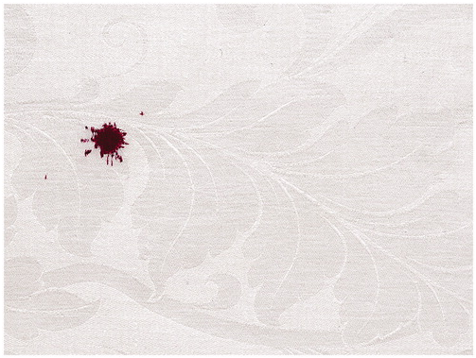

Motivated by the challenge of both in-person and online viewing of her detailed work, Wilson concedes, “The close-up reveal of my work is hard to know or even consider at a distance, or online.” ⁵ Hand magnifiers (sanitized after each use) encouraged close looking by in-person visitors. Also available was Companion Texts—eclectic excerpts on themes evident in the textiles: the first full color image of earth taken from the Apollo 8 spacecraft; a hawk’s pupil at the moment of death; action-painting; the infinitesimal—inspired by studio conversations between Wilson and her former student Casey Carsel during the making of the work last year. Wilson offers, “The themes of living in and through loss seem resonant now and the opportunity to physically experience the work is critical to knowing it.” ⁶ The hand magnifiers, freely available Companion Texts, and video walkthroughs posted online all represent strategies to bring the socially distanced viewer into greater understanding of the physical work. While the experience of in-person viewing is difficult to capture online, the intention these strategies offer is something we can continue to trace in the absence of our own first-hand experience.
Amsterdam-based Finnish artist Kustaa Saksi’s exhibition title First Symptoms feels painfully prescient today. Despite being inspired by the artist’s experience of migraine headaches, each textile uses the proportions and weight of a blanket with patterns that suggest an archive of the restless nightmares now gripping our pandemic world. The latest series follows Saksi’s earlier investigations with themes such as Hypnopompic, the state of sensory confusion between sleep and wakening often described as conjuring hyper-real visual worlds. As with earlier works, the six Jacquard weavings (three exhibited at Galleri Format) were woven at the TextielLab, part of the Textielmuseum in Tilburg, the Netherlands.
For the (gratefully) uninitiated, the experience of migraines and their accompanying visual auras are foreign. Ian McEwan, in his novel Atonement, describes the onset of a character’s migraine with “illuminated points in her vision, little pinpricks, as though the worn fabric of the visible world was being held up against a far brighter light.” ⁷ Saksi discloses, “Being a lifetime sufferer, I have a very personal relationship with my migraine. It’s like an old, slightly tiring friend visiting regularly: always indiscreet and unconditional, never bland. Sometimes the aura takes more trying forms. I will go mute. The words I try to speak or read end up as other words, or not words at all. I will see strange dreams, or smell peculiar aromas.” ⁸ Saksi also offers a list of patterns, “Often geometric structures cover the whole visual field: checkerboards, transparent oriental rugs, tribal patterns, ornamental spherical objets d’art like radiolaria or bacteria, repeating wallpaper designs, spiderweb-like figures or concentric circles and squares, architectural forms or decorative paper-cut snowflakes, mosaics, spirals and swirls.” ⁹ The unfamiliarity of these visual worlds offers us a glimpse behind the artist’s own vision that is heightened through his selection of unconventional yarns—now a longstanding aspect of his weavings.
Despite the fact that I did visit First Symptoms, peering in the winter night-lit windows and later returning during daylight, I have to confess that my eyes still did not understand all that I was seeing. The crimson Aftermath (2019) and In Full Bloom (2019) suggest worm holes, intestines (Figure 5). But writing to the artist after the show I inquired about the white paint layered over the yellow woven ground of Attack (2019) (Figure 6). The materials list is silk, mohair, linen, polyester, rubber and wool. Saksi explained that what I thought was paint, even when standing in front of the work, is a rubber covered yarn.
Figure 5. Kustaa Saksi, In Full Bloom (detail), 2019, Jacquard Weave 165 x 236 cm (66" x 93"). Mohair, Silk, Acryl, Cotton, Wool, Polyester. Edition of 6.
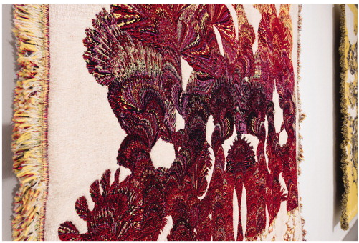

Figure 6. Kustaa Saksi, (left) In Full Bloom, Jacquard Weave 165 x 236 cm (66" x 93"). Mohair, Silk, Acryl, Cotton, Wool, Polyester. Edition of 6 and (right) Attack 2019 Jacquard Weave 166 x 238 cm (66" x 94"). Silk, Mohair, Linen, Polyester, Rubber, Wool. Edition of 6.

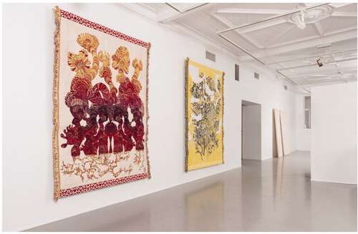

I think it is now possible for me to recall the textiles I saw in Anne Wilson’s studio last autumn, supplement them with text and “see” the photographs of an exhibition I did not experience in person with imperfect, but hopefully adequate accuracy. Ironically, I stood inside Galleri Format and faced Saksi’s Attack but still got it all wrong when I thought I saw white paint on top of the woven textile (certainly not the seeping color of Wilson’s ink on damask) instead of picks of rubber coated thread. Until I was told otherwise, my in-person material understanding was also imperfect. It is possible to support imperfect situations—social distancing, computer screen viewing, lapses in concentration, or sheer material misunderstanding—but only if we remain vigilant. Opportunities to experience art in person remains an ideal, but I have to acknowledge how much effort careful online and in person looking requires. It is careful, even vigilant, looking which Anne Wilson and Kustaa Saksi’s work deserves.

Jessica Hemmings
Jessica Hemmings is a Professor of Craft and Vice-Prefekt of Research at HDK-Valand, University of Gothenburg, Sweden. jh@jessicahemmings.com

Notes
1 https://kustaasaksi.com/About [accessed 28 August 2020]
2 Anne Wilson, If We Asked about the Sky and All That Was Formed from Earth, Companion to Anne Wilson: If We Asked about the Sky, Rhona Hoffman Gallery, Chicago, 2020, edited and annotated Casey Carsel, pp. 16. Available: https://www.annewilsonartist.com/projects/companion-texts-2020.html
3 Ibid., pp. 3.
4 Zoom conversation with the author and Anne Wilson August 22, 2020.
5 Ibid.
6 Ibid.
7 Ian McEwan, I. (2001) Atonement (Vintage) pp. 63.
8 https://kustaasaksi.com/First-Symptoms
9 Ibid.

